

## Semester II 2021-2022

**_______Database Management System**

**Database Systems (CS F212)**

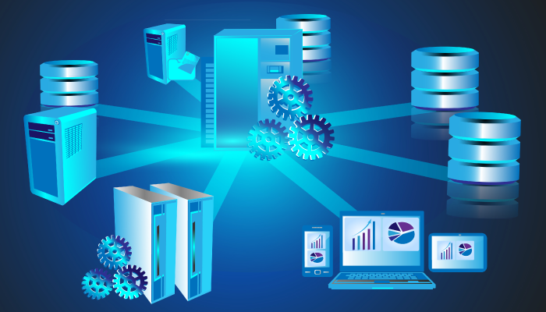

**Done by:**

**Anmol Deepak Kumar - 2020A7PS0221U**

**Ahmed Thahir - 2020A7PS0198U**

**Anurag Kumar Jha - 2020A7PS0128U**

**Ishan Anthony Menezes - 2020A7PS0107U**

**Bharathwaj M - 2020A7PS0080U**

**Date of Submission:05/04/2022**

**Submitted To:****Ms.Sapna Sadhwani**

**ACKNOWLEDGMENT**

I would like to express my sincere gratitude to all Department of Computer Science Professors for allowing us to apply my expertise in this assignment.

My humble and noteworthy appreciation is due to Ms.Sapna Sadhwani and Dr.Tamizharasan Periyswamy for being there to answer our queries. I am thankful to him for all the guidance and assistance he gave for the completion of this assignment.

I am also grateful to all the Department of Computer Science faculty for giving us the required knowledge to program using the sql programming language for Database Systems

***CONTENTS***

1. Discussion 4
2. ER Diagram x
3. Relational Schema xx
4. Normalization
5. SQL Tables
6. SQL Queries
7. Connect to Database
8. GUI Images

# DISCUSSION

The __job____ industry is booming with over ____ million customers in the year 2019. One of the most crucial elements which the job industry depends upon is the Database Management System for every Airline, which is used to store, organize and retrieve the details of all the Staff, Passenger bookings, Airline and Aircraft details, Arrivals, Departures, Finances, and many more segments. This requires a robust and efficient design of the Database to manage the data so that it can be accessed, modified, and stored quickly, and in the least space. A DBMS may also be called a “Transaction Processing System”. A transaction is the basic atomic unit of a DBMS and hundreds of transactions take place every minute concurrently. A transaction may be a Search, Delete, Update or Insert operation into the database. The Database system and SQL commands described in this report makes up the basic operations of the airline such as reservation, cancellation, and updating of a flight trip data

**FEASIBILITY AND RISK ANALYSIS**

These are the following risks as per our analysis:

Resource availability:

• Are the necessary skilled staff and computation available to develop this system?

Development Risk: • Can a system be developed so that it satisfies the pre-decided operational benchmarks and limits?

Technology: • Has the technology progressed to a state that will support the system?

Our answer is that Yes, we currently are able to account for these risks in a proper manner. The resources that are needed to develop this system are present with us, we are the only staff who are working on this project, and we are satisfied that we will manage to execute this project within the given constraints with our current programming ability

**ER Diagram**

This section describes the logic behind the relations between all the different databases in our designed DBMS for Airline Reservation System. We start with the Airport table. The Airport is an independent entity, identified uniquely by a code with an address as an important attribute. The address is a composite attribute as it contains different attributes under it, and similarly, we define other attributes for different entities in the report. In the Airline relation, and each plane of the airline has access to the Airport.

**TABLES AND PRIMARY KEYS**

**Relational Schema**

A relational database schema is the tables, columns, and relationships that make up a relational database. Purpose: A relational database schema helps us to organize and understand the structure of a database. This is particularly useful when designing a new database, modifying an existing database to support more functionality or building integration between databases. Creating the Schema: There are two steps to creating a relational database schema: creating the logical schema and creating the physical schema. The logical schema depicts the structure of the database, showing the tables, columns, and relationships with other tables in the database, and is a direct mapping of the Entity-Relationship diagram. The physical schema is created by actually generating the tables, columns, and relationships in the relational database management software (RDBMS) i.e SQL queries to create the database tables and relationships define

**Normalization(3NF)**

**Other stuff adding**

## REFERENCES

Websites:

1. https://[www.](http://www.onlinegdb.com/online_c_compiler)

Videos:

1.